**Lab 11**

**Objectives**

The objective of simulating Joey’s Barbershop using GPSS is to model and analyze customer arrival patterns, service times, and the use of facilities (barber stations) to understand the efficiency of the barbershop's operations. The simulation will account for the random variation in both customer arrival times and the time it takes Joey to cut hair, using the facility block to represent the barber station. By running the simulation for 9 hours, the goal is to assess the barbershop's performance, determine average wait times, identify potential bottlenecks, and optimize service delivery. Similarly, simulating a random walk or drunkard’s problem aims to study the movement patterns of a random entity, exploring concepts like probability, randomness, and the statistical behavior of paths, which can be applied to fields such as physics, economics, and computer

**Q.1. Customers arrive at Joey’s Barbershop one every 15±3 minutes and it takes Joey 18±2 minutes to cut hair of a customer. Write a GPSS program to simulate a Barbershop using the concept of facility and run the simulation for 9 hours.**

**Source code:**

GENERATE 15,3

QUEUE BARBERQ

SEIZE JOEY

DEPART BARBERQ

ADVANCE 18,2

RELEASE JOEY

TERMINATE 1

JOEY STORAGE 1

START 540

**Output:**

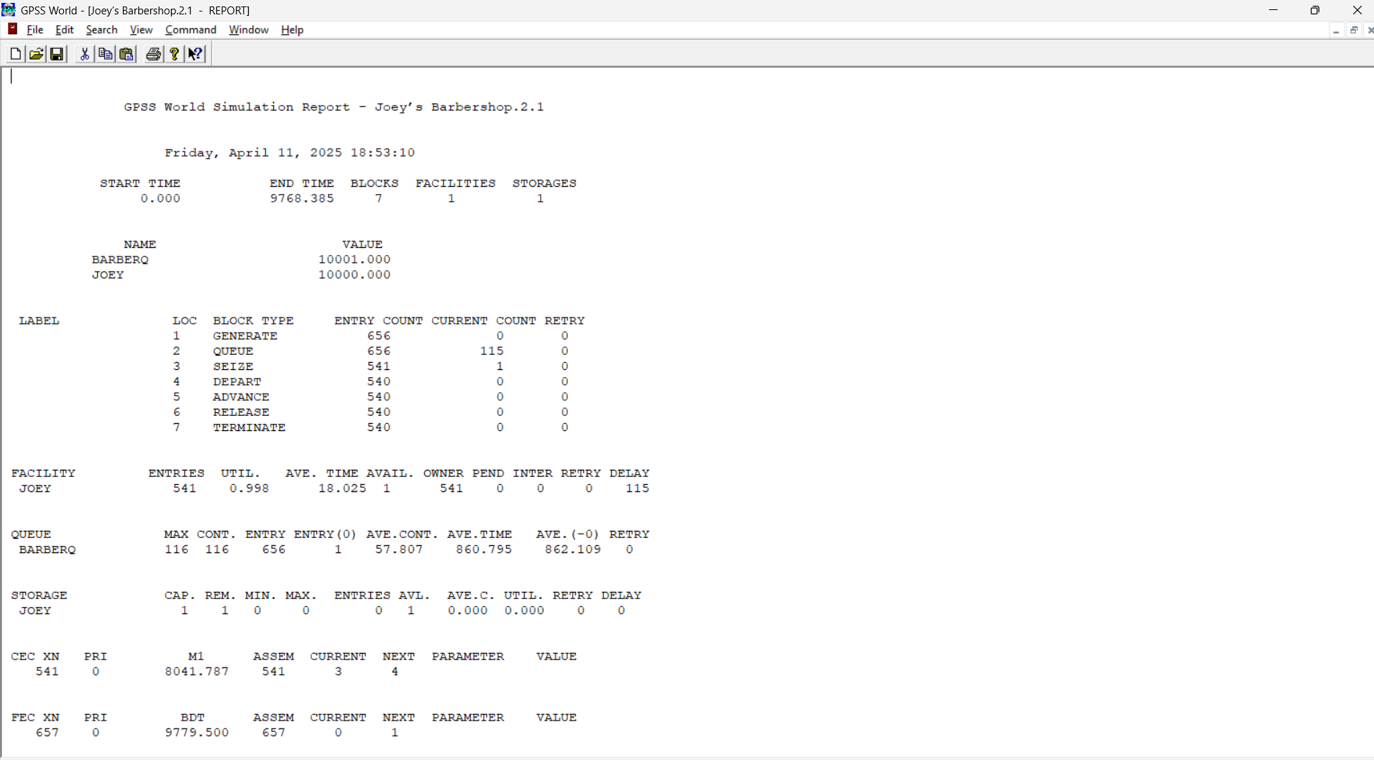

**Q.2. Simulate random walk problem or a drunkard problem in any programming language.**

**Source code:**

#include <stdio.h>

#include <stdlib.h>

#include <time.h>

int main() {

int position = 0;

int steps, i;

printf("Enter number of steps: ");

scanf("%d", &steps);

srand(time(0));

for (i = 0; i < steps; i++) {

if (rand() % 2 == 0)

position--;

else

position++;

}

printf("Final position: %d\n", position);

return 0;

}

**Output:**

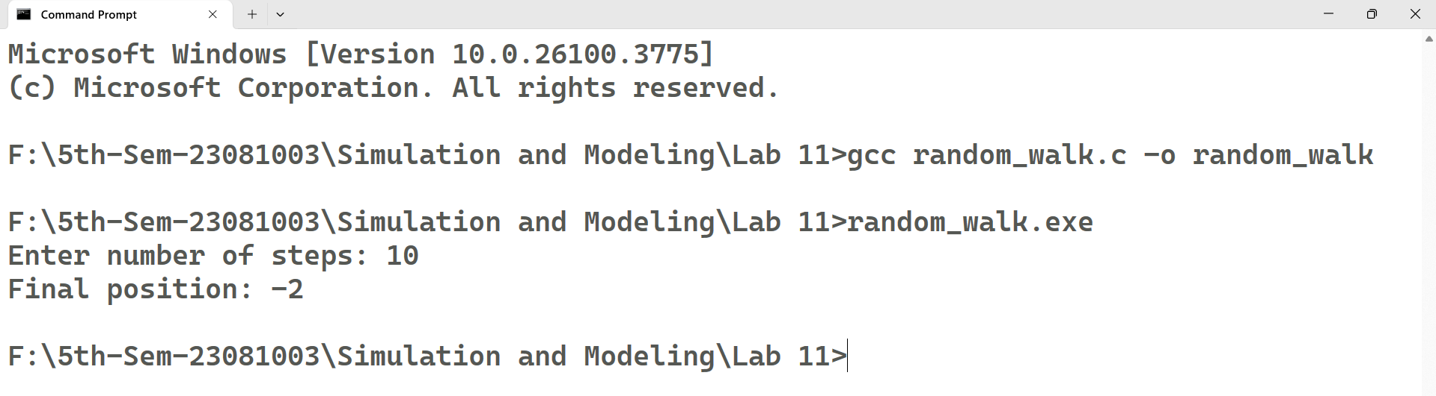

**Conclusion**

In conclusion, the simulation of Joey’s Barbershop using GPSS provides valuable insights into how random customer arrivals and service times impact overall system performance. By modeling the barbershop's operations with varying arrival rates and service durations, the simulation helps identify potential inefficiencies, such as long wait times or underutilized resources. The results can guide improvements in resource allocation, service strategies, and customer flow management. Similarly, simulating the random walk problem demonstrates the importance of understanding randomness and probabilistic behavior in various systems, offering a deeper understanding of path prediction and statistical analysis in fields such as physics and finance. Both simulations emphasize the role of randomness and variability in shaping real-world system performance and decision-making.